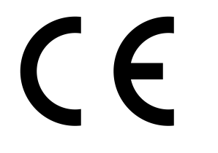
EC Declaration of Performance

Lime Green Products Ltd, Coates Kilns, Stretton Road, Much Wenlock, Shropshire, TF13 6DG

15

Finish WP

EN 998–1:2010

Factory Made Coloured Rendering Mortar (CR) for external use

Reaction to fire: Class B1

Strength Class CSII

Adhesion: >0.08 (woodfibre)

Capillary Water absorption: W2

Water vapour Permeability coefficient. µ ≤ 10

Thermal conductivity λ10,dry [W/mK] P=50% 0.47
P= 90% 0.54

Durability (against freeze/thaw): evaluation based on provisions valid in the
intended place of use of the mortar

Date 22/1/15

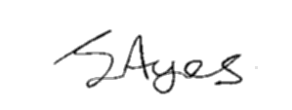
Signed

J Ayres – Director

